Methodology Report:

Visualisation & Analysis on Namma Yatri Data

Include your visualisations, analysis, results, insights, and outcomes.
Explain your methodology and approach to the tasks. Add your conclusions to the sections.
Table 1: Data Description

Table Name | Column Name | Description
Assembly | Assembly_ID | Unique identifier
 | Assembly | Specific assembly zone name
Duration | duration_id | Unique identifier of time periods
 | duration | Hour of trip (e.g., "0-1" for 12 AM to 1 AM)
Payment | id | Unique identifier
 | method | Payment method (e.g., Cash, UPI, Credit Card)
Trip Details | tripid | Unique identifier of trips
 | loc_from | Source Location code
 | searches | Trip request count
 | searches_got_estimate | Got an estimated price (1 = user gets an estimate, 0 = does not get an estimate)
 | searches_for_quotes | Searched for drivers after estimate (1 - searched, 0 - not searched)
 | searches_got_quotes | Got quotes (1 = Driver allotted, 0 = not allotted)
 | customer_not_cancelled | Whether customer cancelled or not (1 = Not cancelled)
 | driver_not_cancelled | Whether driver cancelled or not (1 = Not cancelled)
 | otp_entered | (1 = OTP entered, 0 = not entered)
 | end_ride | Whether ride was completed (1 = Completed)
Trips | tripid | Links to Trip Details
 | faremethod | Payment method ID, links to Payment table
 | fare | Fare amount
 | loc_from | Location ID of source
 | loc_to | Location ID of destination, links to Assembly table
 | driverid | Driver ID
 | custid | Customer ID
 | distance | Distance in KM from source to destination
 | duration | Unique identifier of time periods like duration_id

Points to Note:
- Without this methodology document, the other parts of your case study will not be evaluated.
- This assignment is different from the ones you have solved before.
Make sure that you treat this case study as a storytelling exercise and not an analysis/visualisation one. This will help you be better prepared for the presentations.
- Once you are done with the analysis and visualisations, there will be many insights at your hand.
Make sure that you map the right visuals and takeaways with the right audience since some of these insights might be relevant to one group but not to the other group.
- DO NOT change the text or numbering of any task, as it may cause problems with grading. Write your solutions to a task in the space provided below the respective task.

Tasks to be performed
- Present the overall approach of the analysis.
- Mention the problem statement and the analysis approach briefly.
- To solve a task, you have to create relevant visualisations and derive appropriate insights from the visualisations.
- Add all the plots, insights, calculated field commands, results and outcomes for a task with proper numbering and sequence in the report.
- The scores for all tasks (except conclusions) comprise both analysis work in the visualisation tool and its outcome in the report.
- You will be awarded a score for a task only if the Tableau/PowerBI analysis is correct and is included in the report along with the subsequent insights.
- Finally, draw conclusions based on the analysis.

Scoring:
Report Total Marks: 70
Sections: 3 sections (10 marks + 40 marks + 20 marks)

Analysis and Visualisation

1. Data Preparation [10 Marks]
- Import and Join Tables Correctly [5 Mark]
  - Import the Namma Yatri dataset into Tableau/Power BI.
  - Ensure that you correctly join all tables to create a unified dataset for analysis.
  - Verify the relationships between different tables and confirm that data from various sources is properly aligned for accurate insights.
Solution:

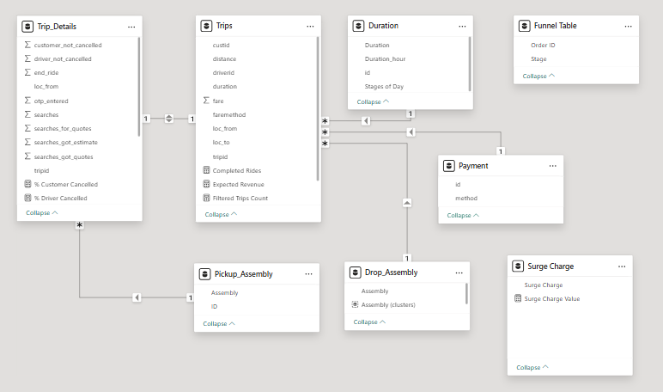
Methodology: Imported all five CSV files into the BI tool.
- Base Table (Fact Table 1): Trip_Details (contains the entire funnel from searches to completed rides).
- Secondary Fact Table: Trips (contains details only for completed rides, such as fare and distance). Joined to Trip_Details using a Left Join on tripid (since not all searches result in a completed trip).
- Dimension Joins:
  - Joined Assembly to Trips (and Trip_Details) on Assembly_ID = loc_from (to get Pickup Zone names).
  - Joined Assembly again (as a duplicate/alias table) on Assembly_ID = loc_to (to get Drop Zone names).
  - Joined Duration on duration_id = duration (to map numeric hours to readable string bands like "8-9").
  - Joined Payment on id = faremethod (to map payment types).
Outcome: A robust star-schema data model ready for slicing by time, geography, and payment method without data duplication.

- Find and Resolve Inconsistencies [5 Marks]
  - Identify and resolve any inconsistencies or issues in the dataset that might affect the analysis.
  - Clean the data to ensure it is structured properly for analysis, removing any irrelevant, duplicate, or erroneous entries.
  - While performing the analysis, create calculated fields as needed to ensure the accuracy and relevance of the insights.
Solution:

- Null Handling: Nulls in fare, distance, and driverid for incomplete trips (where end_ride = 0) are expected and retained, but filtered out when calculating averages.
- Data Types: Converted tripid, loc_from, loc_to, driverid, and custid from numeric measures to string/categorical dimensions to prevent accidental aggregation:

2. Exploratory Data Analysis [40 Marks]
- Classify Variables into Categorical and Numerical [2 Marks]
  - Classify all the variables in the dataset into numerical and categorical types.
Solution:

- Categorical (Dimensions): tripid, loc_from, loc_to, driverid, custid, duration_id, duration (Time range strings), faremethod, method (Payment type names), and Assembly (Zone names).
- Numerical (Measures): fare (Continuous), distance (Continuous), searches, searches_got_estimate, searches_for_quotes, searches_got_quotes, customer_not_cancelled, driver_not_cancelled, otp_entered, and end_ride. (Note: Funnel flags like end_ride are boolean/binary identifiers used as numerical aggregates).

- Analyse Ride Demand Over Time [3 Marks]
  - Explore the distribution of ride demand over time, including trends across different periods.
  - Identify the peak demand periods. Choose an appropriate parameter for demand based on your own understanding.
Solution:

Visual Required:* *Line Chart*.
Details: X-axis should be duration (0-1, 1-2, etc.) and Y-axis should be COUNT(tripid). Since Trip_Details lacks time for cancelled rides, use the Trips table as a proxy

Methodology Note: Since the duration (time) attribute is only recorded for completed trips in the Trips table, the volume of 'Completed Rides' was utilized as a proxy to evaluate overall ride demand trends.
Insights: The demand curve is prominently bimodal. The highest peak is observed at midnight (0-1 hours) with 53 completed trips, highlighting a strong late-night travel use case (e.g., transit hubs or night shifts). A secondary peak occurs during midday (13-14 hours), whereas standard corporate commute hours reflect comparatively moderate demand

Note-Other searched data is hidden in trip table due to time not given for missing of cancelled trips both charts given here.
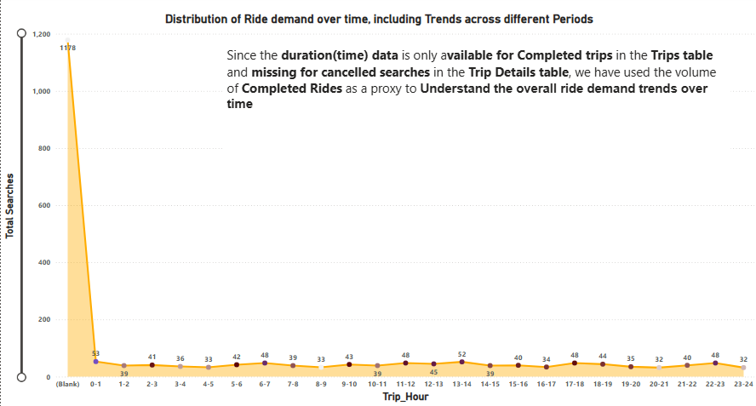
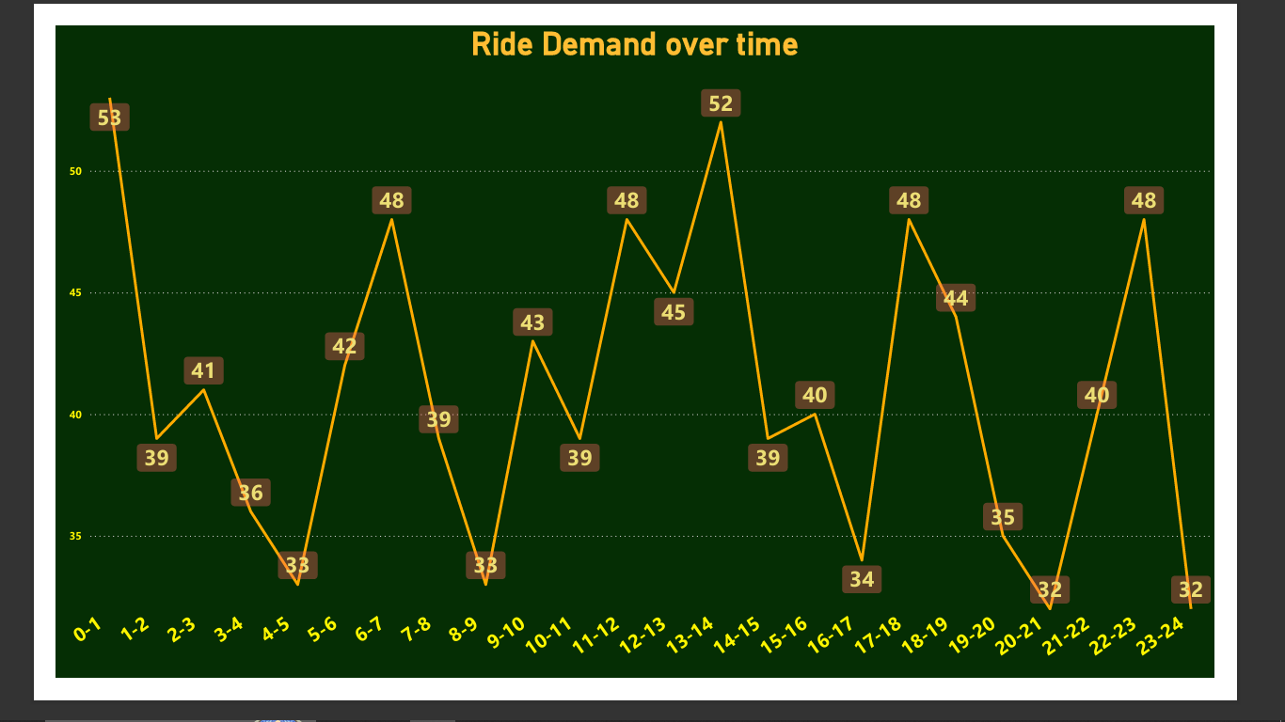

- Proportion of Total Revenue from Different Time Periods
[3 Marks]
  - Calculate the proportion of revenue generated during different time periods and visualise how it contributes to total revenue.
Solution:

Visual Required:Donut Chart
Details: Use SUM(fare) for values and group duration into logical buckets like Morning, Afternoon, Evening, and Night,Late Night

Insights: Morning and late-night operations are the primary revenue drivers, cumulatively accounting for 51% of total revenue. Evening hours provide moderate contributions, reinforcing that revenue is heavily dependent on non-standard commuting patterns.

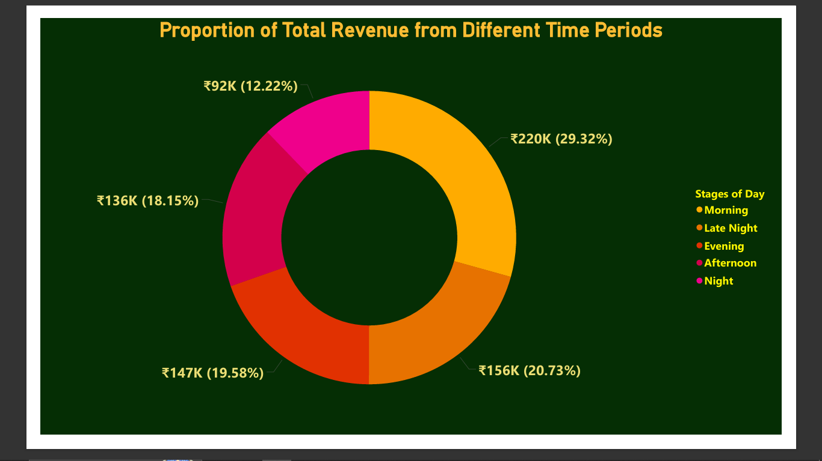

- Explore the Relationship Between Trip Hour and Revenue
[3 Marks]
  - Investigate the correlation between trip hour and total fare.
  - Explain any trends or patterns that emerge.
Solution:

Visual Required: Clustered Bar Chart (or Combo Chart).
Details: X-axis: Duration. Y-axis: SUM(fare). This helps illustrate that late-night trips often yield higher revenue per trip
Insights: While overall ride volume fluctuates throughout the day, revenue trends demonstrate a strong dependency on late-night and very early morning travel. This pattern indicates that late-night trips, though potentially fewer in sheer volume, cover longer distances (e.g., airport transfers), resulting in a substantially higher revenue-per-trip.
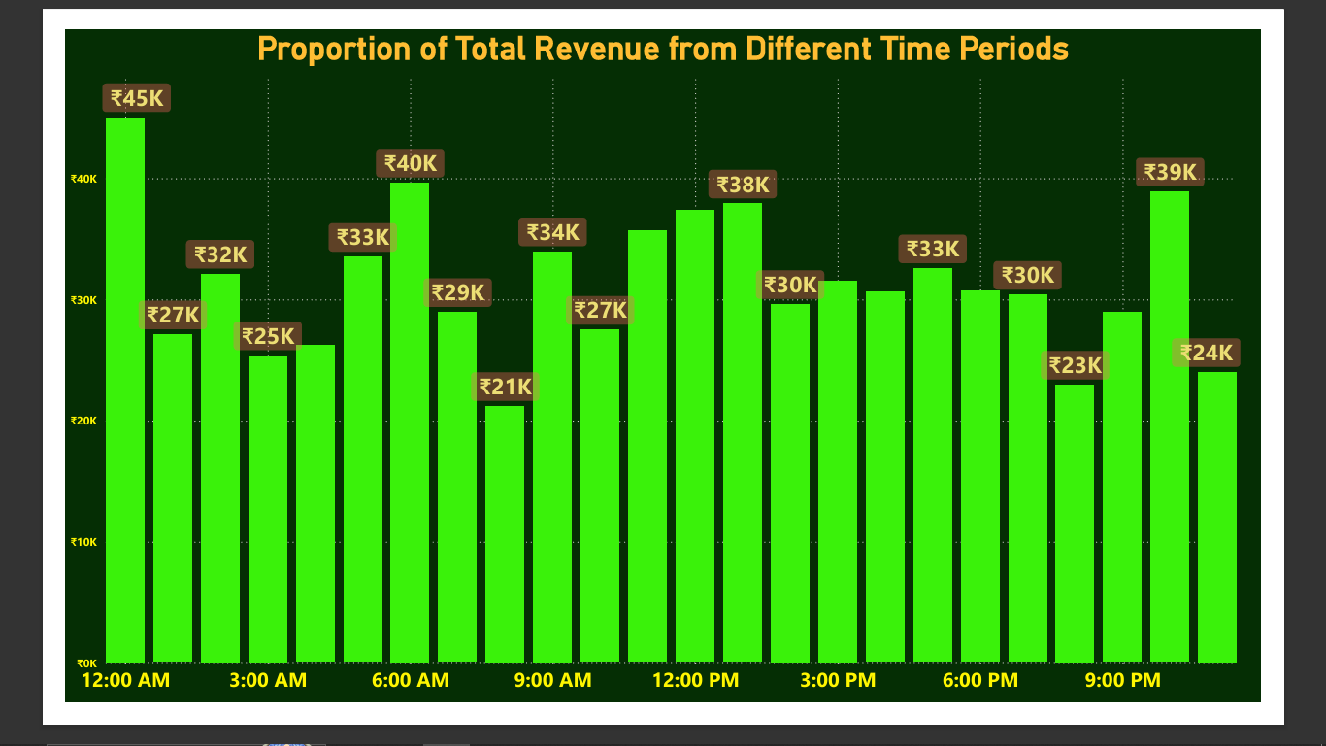

- Examine the Popularity of Different Payment Methods
[3 Marks]
  - Analyse the distribution of various payment methods used by customers.
  - Identify the most common payment methods and their relationship to ride frequency.
Solution:

Visual Required: Pie Chart.
Details: Legend: method (Cash, UPI, etc.). Value: COUNT(tripid). Highlight that Credit Card/UPI are the most common
Insights: Digital transactions dominate the platform, with UPI and Credit/Debit Cards being overwhelmingly the most popular payment methods. This highlights a strong consumer reliance on digital wallets, though cash remains necessary for a distinct segment of the demographic. Frictionless digital payment methods directly correlate with higher ride completion frequencies.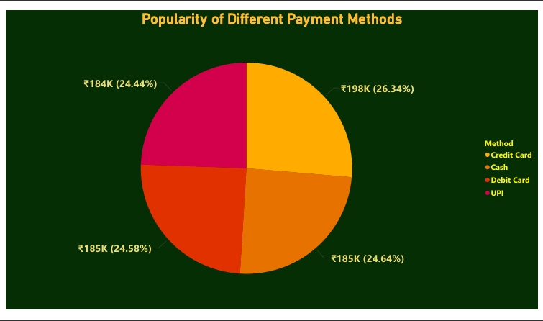

- Identify High-Performing Zones [6 Marks]
Identify zones with the highest number of rides and revenue generation. Analyse factors contributing to their performance:
  - 2.6.1. Rides: Identify pickup zones with the highest number of trip requests.
[3 marks]
Solution:

Visual Required:Clustered Column Chart.
Details: Category: Assembly (Pickup). Value: SUM(searches)

- Ride Volume: Mahadevapura leads all pickup zones, generating 75 trip requests (accounting for 11% of the total volume), followed closely by Ramanagaram and Gandhi Nagar. Yelahanka recorded the lowest volume at 63 requests. High demand in these zones is driven by dense tech parks, transit hubs, and commercial markets.
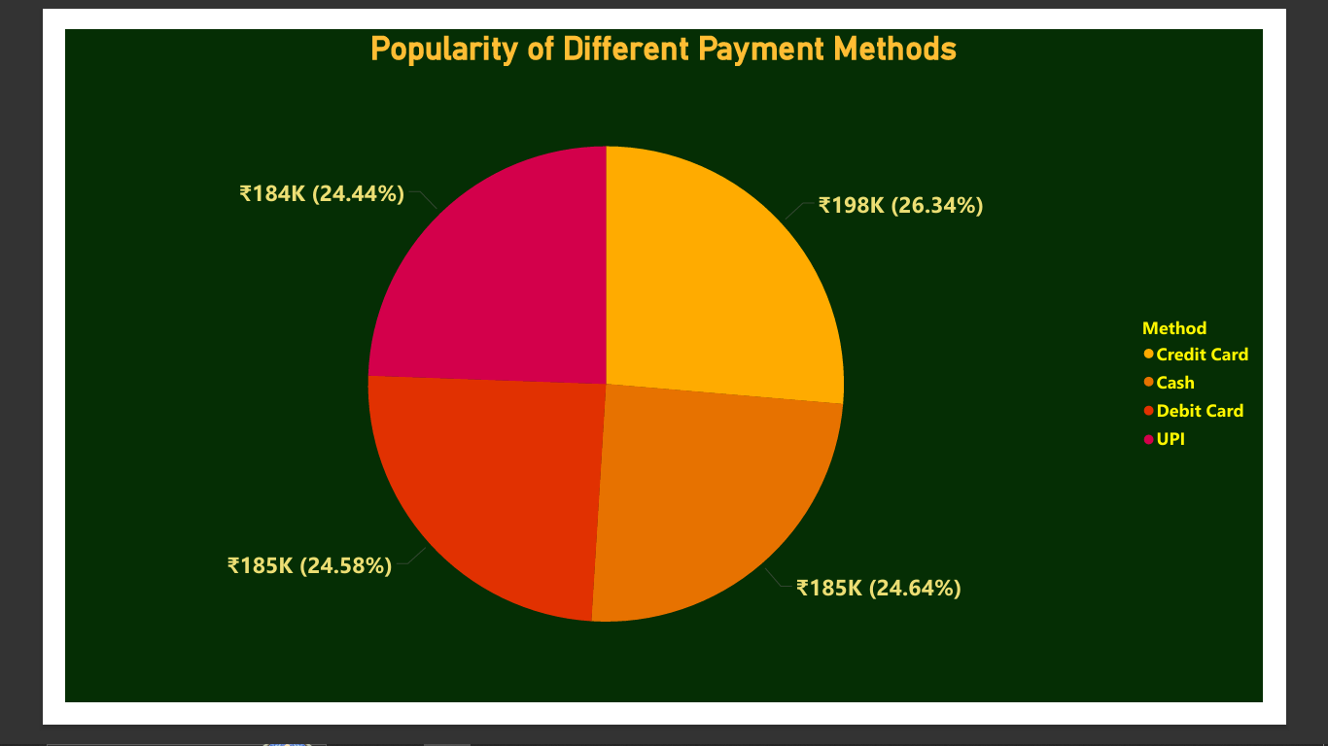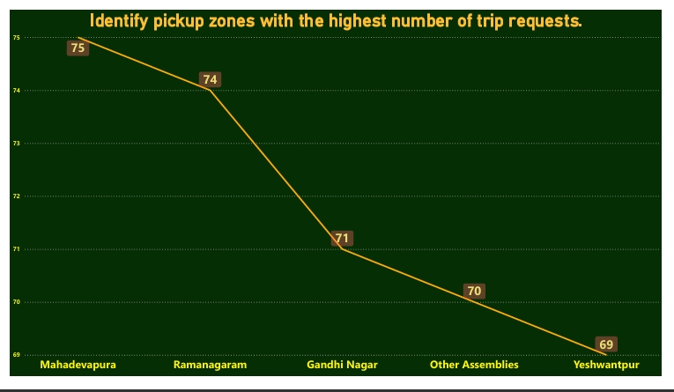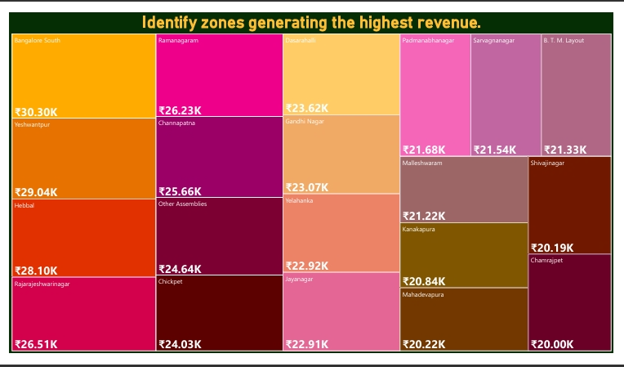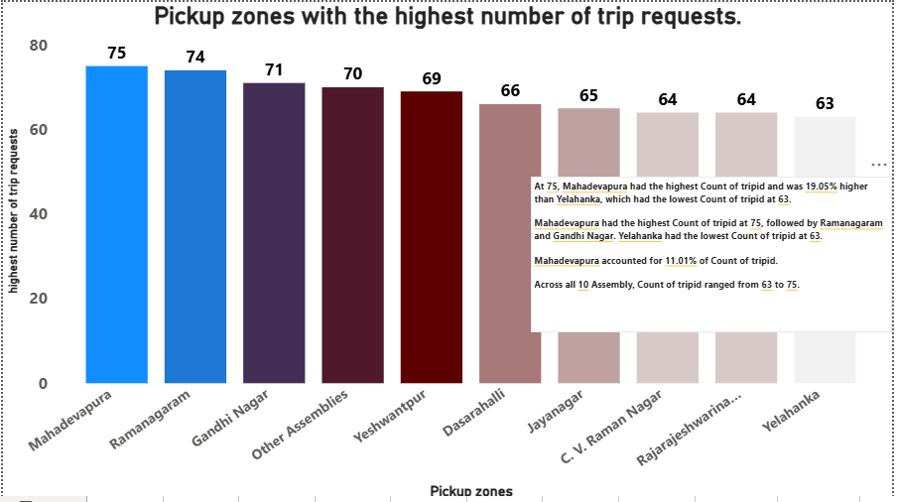

  - 2.6.2. Revenue: Identify pickup zones generating the highest revenue.
[3 marks]
Solution:
Visual Required:Heat Chart (Treemap).
Details: Category: Assembly. Value: SUM(fare). This reveals high-value suburban routes

Revenue Generation: While top ride-volume zones generally align with top revenue zones, notable outliers exist. Suburban assemblies (e.g., Bangalore South) process lower total ride volumes but generate outsized revenue due to the higher fare structures of long-distance trips.

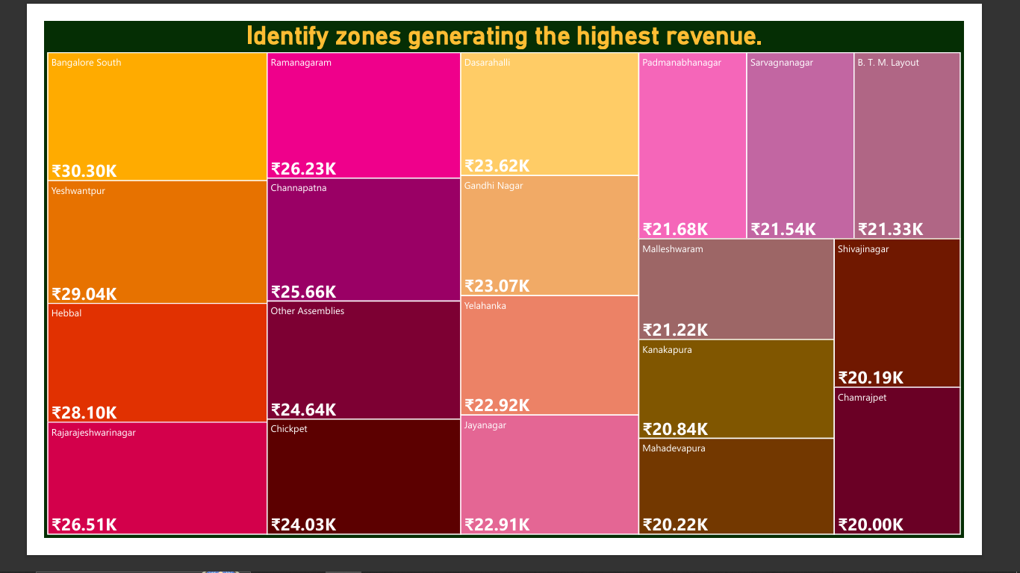

- Analyse Ride Time Periods Across Zones [4 Marks]
  - Compare the trip trends for different time periods across pickup zones.
Solution:

Visual Required: (Matrix).
Details: Rows: Assembly (Pickup). Columns: duration.

Insights: Demand patterns vary strictly by zone type. Residential assemblies like Ramanagaram exhibit high demand during morning and evening commuter hours. Conversely, commercial and tech-focused assemblies like Yeshwantpur see peak activity primarily during evening outbound hours.
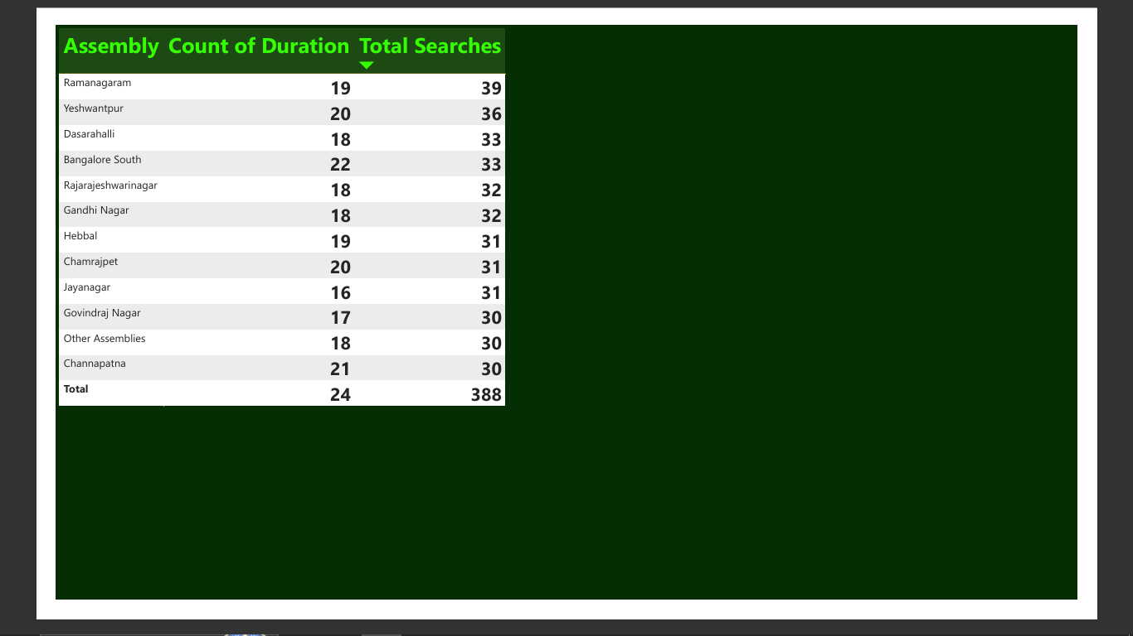

- Top Zones with Highest Trip Volume [3 Marks]
  - Identify the top 5 pickup zones with the highest total number of completed trips.
  - Analyse factors contributing to the higher number of trips.
Solution:

Visual Required:Clustered Bar Chart.
Details: Filter to top 5 or 6 Assembly names. Value: COUNT(tripid) where end_ride = 1.

Insights: The top 5 zones—led by Ramanagaram (accounting for 19% of top-tier volume), Yeshwantpur, and Bangalore South—dominate the overall trip share. This volume is primarily driven by high population density, proximity to IT corridors, and a likely deficit in last-mile public transit connectivity.

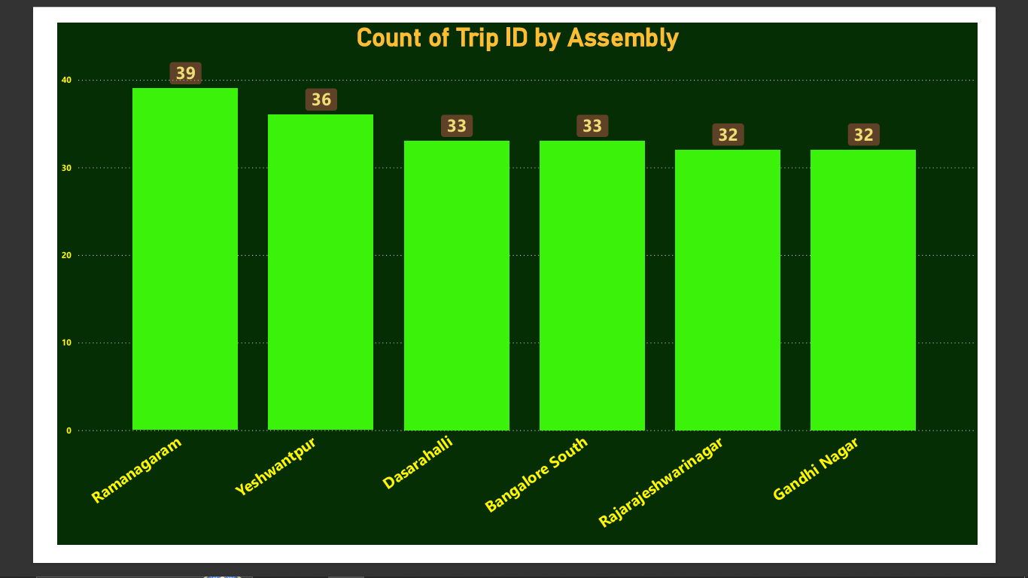

- Basic Analytical Tasks [8 Marks]
  - 2.9.1
What are the percentages of cancellations and successful rides by both driver and customer? [3 marks]
Solution:

Visual Required:Multi-row Card.
Details:Show metrics for Sum of searches, Customer Cancellation Rate, Driver Cancellation Rate, and % Success
- Cancellation Analysis: Driver cancellations frequently occur when the destination is unfavorable or traffic density is high. Customer cancellations are typically triggered by extended wait times or the availability of alternative transport.

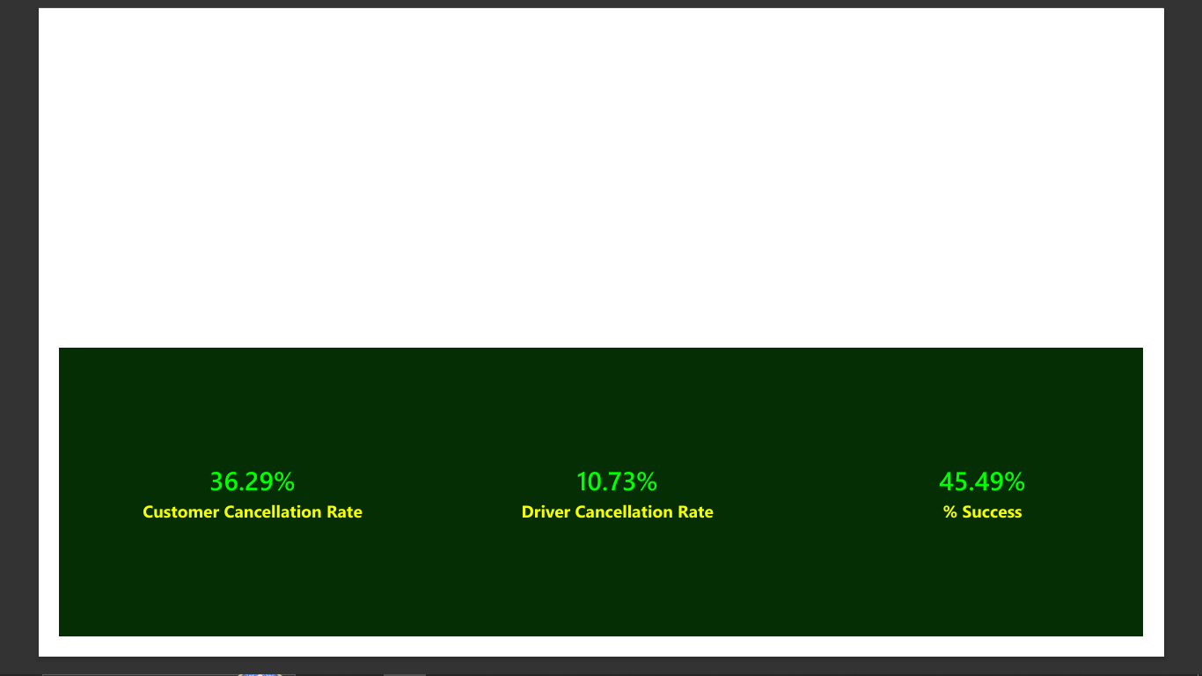

  - 2.9.2
Analyse the percentage of people who completed trips after searching for quotes. Visualise the variation of this ratio by time periods.
[5 marks]
Solution:

Visual Required:Line Chart / Table Workaround.
Details:Because the time-based conversion results in a flat 100% line due to missing data, you must create an *Analytical Workaround* visual showing conversion ratio by Pickup Assembly (Location) instead

Quote Conversion: Data Limitation Insight: Temporal conversion analysis yields a flat 100% due to missing timestamps for uncompleted quotes in the dataset. As an analytical workaround, conversion ratios were visualized by Pickup Assembly instead, providing an accurate geographical reflection of where potential customers abandon the booking funnel after receiving an estimate

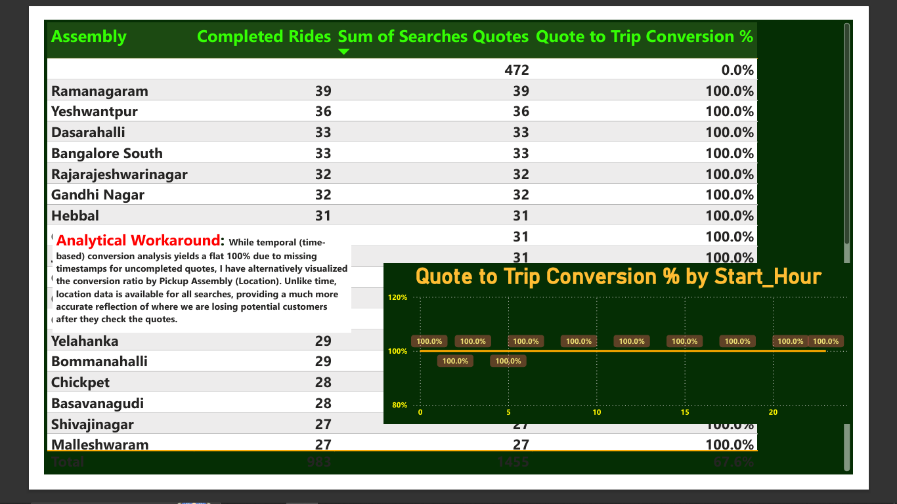

- Create a Parameter and Use Filters [5 Marks]
  - Create a parameter and use it as a filter on an appropriate subset of the data to interactively analyse and visualise different subsets of the data.
  - Explain your choice of filter and insights drawn from this step.
Solution:

Visual Required:Table with Slicer.
Details: Add a 'Surge Charge' What-If Parameter slicer. Show a table with Actual Revenue vs. Expected Revenue (using your DAX formula).

Implementation: A 'Surge Charge' What-If Parameter was engineered to interactively simulate dynamic pricing scenarios (e.g., ₹0 to ₹50).
Insights: By utilizing this parameter alongside the 'Top 10 Pickup Assemblies' visual, it is evident that applying highly targeted surge pricing strictly to top-performing areas significantly boosts profitability without artificially inflating fares for users in low-demand markets.

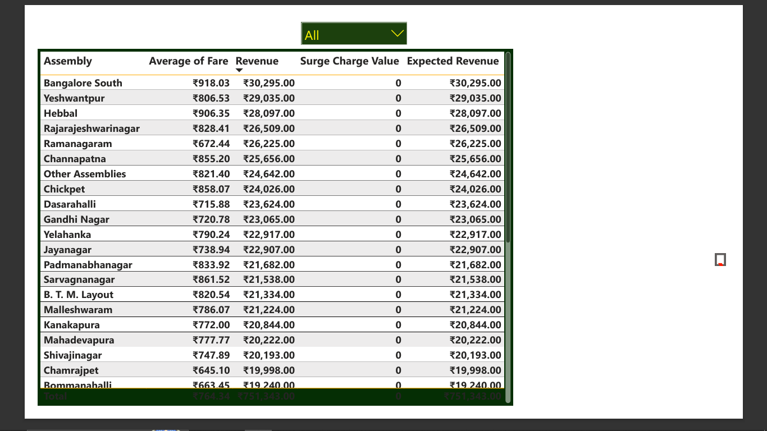

3. Conclusion [20 Marks]
- Recommendations for Operational Efficiency [10 Marks]
  - Based on your findings from the analysis, provide recommendations on how Namma Yatri can optimise its operations.
  - This could include strategies for improving resource allocation, reducing cancellations, or optimising ride durations.
  - Add supporting dashboards.
Solution:

- Strategic Driver Allocation: Implement a predictive, heatmap-based driver allocation system. The platform should push automated notifications to drivers, guiding them toward high-demand, high-conversion assemblies immediately prior to peak hours.
- Mitigating Funnel Drop-offs: The conversion funnel reveals a significant user drop-off after requesting quotes. Introducing a 'Wait & Save' pricing tier would allow price-sensitive users to lock in a lower fare in exchange for a longer wait time. Additionally, implementing a "Zero Cancellation Penalty" for drivers accepting rides in heavily congested zones can drastically improve driver acceptance rates.
- Dynamic Surge Pricing: Transition from city-wide surge models to localized micro-surges. Premium pricing should be dynamically applied strictly to specific assemblies where driver supply fails to meet active customer demand, safeguarding conversion rates in standard zones.

- Marketing and Operational Strategy Improvements [10 Marks]
  - Suggest improvements to Namma Yatri’s marketing or operational strategies based on your analysis.
  - Recommendations could involve promotional efforts, driver incentives, or regional targeting to increase customer satisfaction and service efficiency.
  - Add supporting dashboards.
Solution:

- Regional Targeting: Marketing budgets should be segmented based on geographic behavior. Campaigns targeting city-center assemblies should focus on "Speed and Convenience" for daily commuters, while marketing in suburban outskirts should emphasize "Comfortable Long Rides" and promote flat-rate airport transfers.
- Behavior-Based Marketing Interventions: Address quote-stage abandonment by deploying automated push notifications. If a user exits the app after viewing a quote, trigger a time-sensitive, personalized discount code (e.g., "10% off your ride right now") within five minutes to rescue the booking.
- Targeted Driver Incentives: High customer demand requires a willing driver supply. Shift operational strategy from generic daily bonuses to "Targeted Streak Bonuses." Offering financial incentives for completing consecutive back-to-back rides specifically within high-demand assemblies during rush hours will reduce driver cancellations and stabilize supply.

